Client Name:
Site 8: Angelica Mendoza - 979-574-8136
Site 9: Maria Mendoza - 979-213-3930

Client Address:
5468 Koppe Bridge Rd, College Station, TX 77845
Site 8: Angelica Mendoza - #44
Site 9: Maria Mendoza - #42
Phone Number:

Distance from the Church:
2.2 miles – 6 minutes

Description of the work:
2 decks, 2 stairs, 2 mobile homes, 2 demo
Spanish
Homeowners association =(

Site Pictures

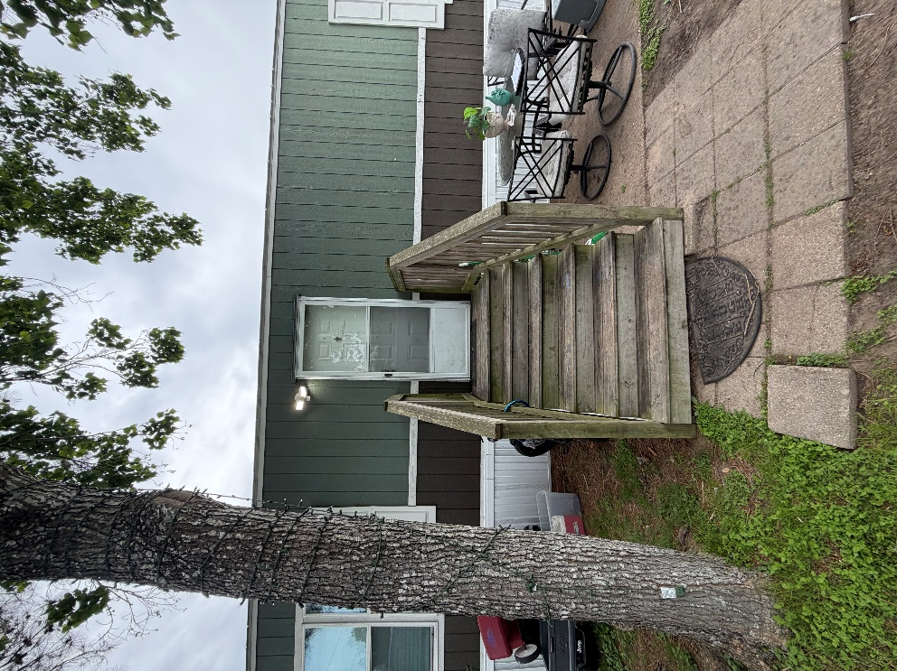
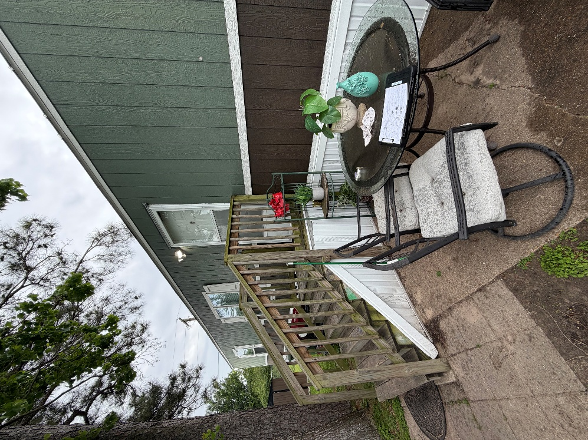
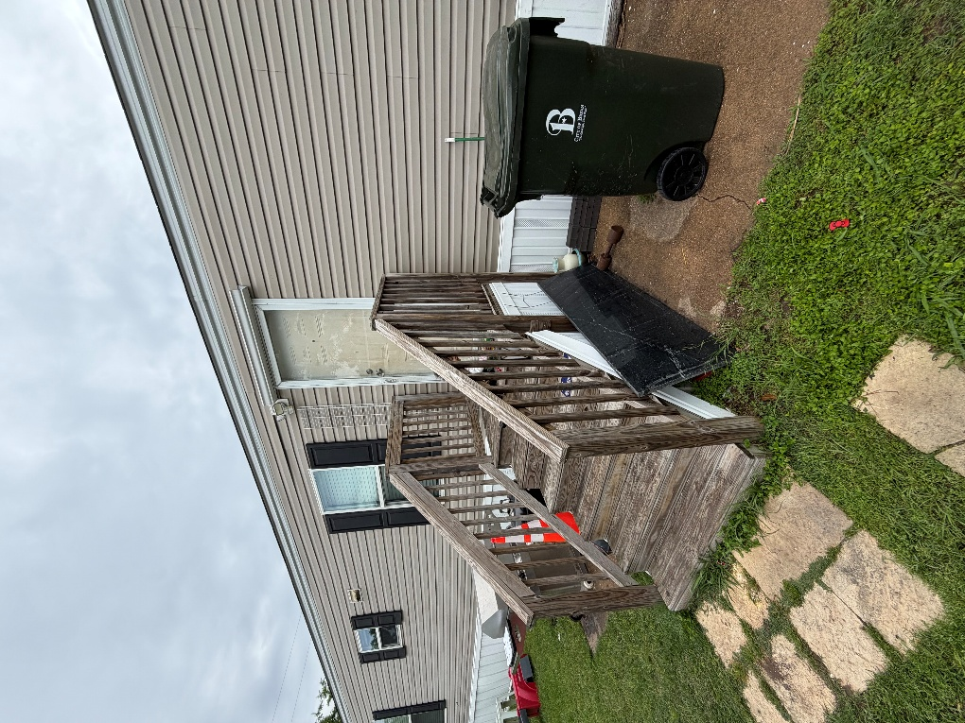
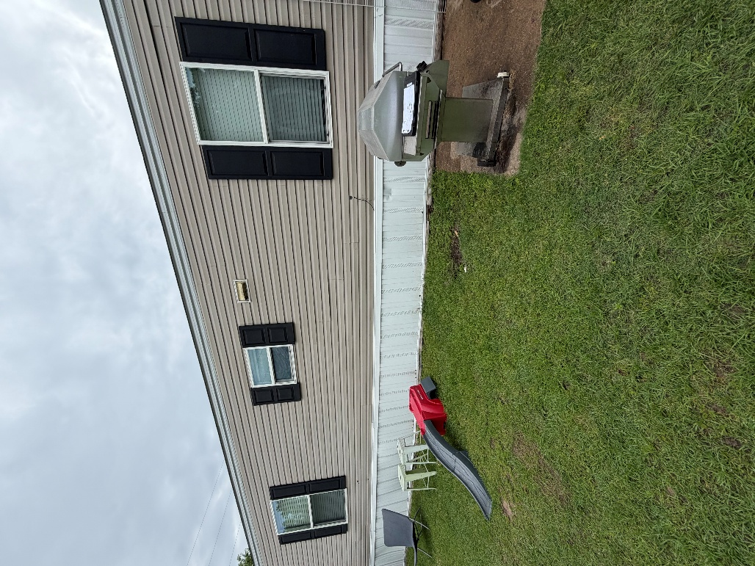
Rendered Project
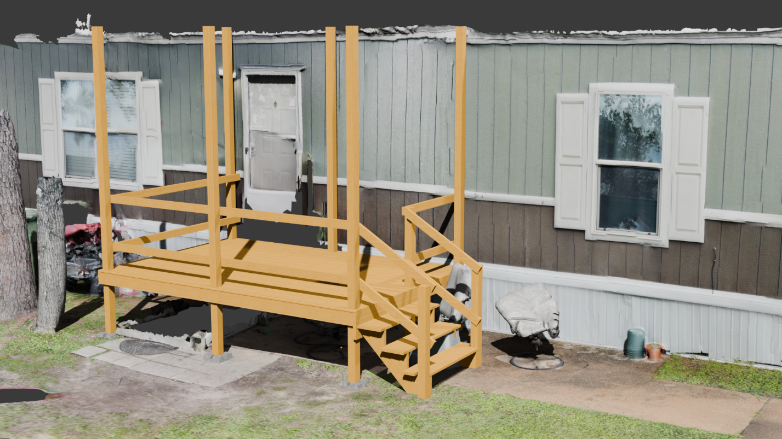
“Build to site not to plan”
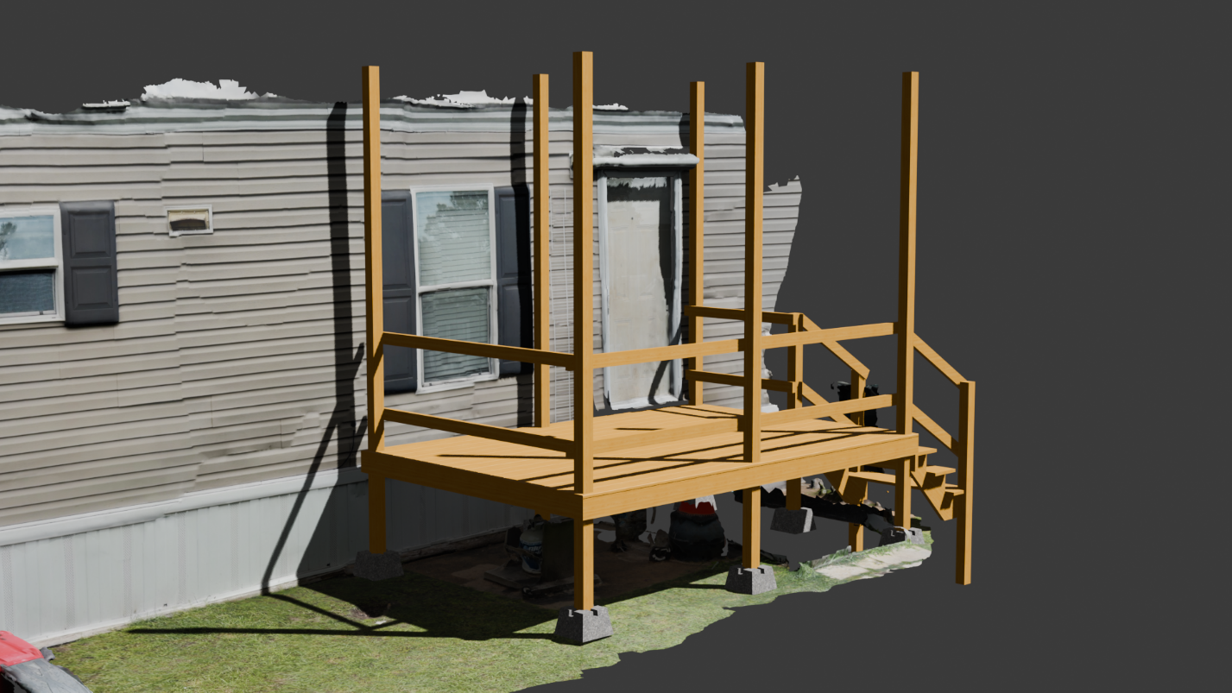
Building Notes
- Build the handrails so a 36in baluster can be added
  - Attempt to reuse balusters from stairs
- Did not plan to put deck boards on handrails
  - Post will be kept high client will add a roof
- Use three stringers on stairs
- Posts holes not over concrete have to be “3 feet down”
  - (18-20 inches)
- Skirting will need to be installed

